Health Awareness
Seminar
Guest Speakers:

Ann & Bill Goodrich
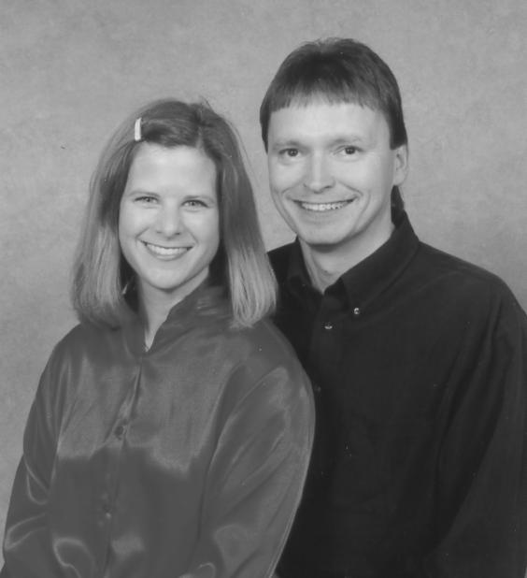

Ann is an elementary teacher from

Glenwood City, WI who has suffered
from Fibromyalgia. She is now free
from the pain of this disease without
the use of prescription drugs.

This is a story that will warm your
heart and give you hope.
Join us on
Tuesday, October 8th, 2002
6:30 p.m. to 8:00 p.m.

Tom & Kris XXX Home
XX49 Red XXX Drive
Eau Claire, WI

Please take the time to attend this meeting, the information is free.
Question and answer time and informational handouts will be provided.

Seating is limited.
Reserve your seats today!!
Call: (715) XXX-XX70
email: XXXX@XXX.XXX

Event sponsored by members of the Cancer Prevention Coalition.
& Independent Distributors of Neways International

